Application Governance Cube Validation :

SELECT c.app_owner_validity_flag_c,

Count(1) as cnt

FROM ldb.f_rita_application_c_fact a

JOIN ldb.d_rita_application_c b ON a.rita_application_c_key=b.row_key

JOIN ldb.d_rita_application_ext_c c ON b.rita_application_ext_c_key=c.row_key

group by 1;

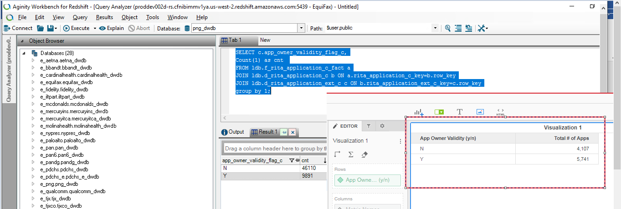

Issue 2: ‘Employee Type’ attribute should come from the d_internal_contact and hence , UNKNOW and UNSPECIFIED should not come.

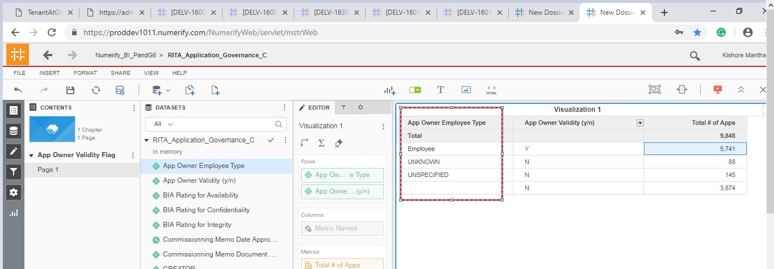

Issue 3: ‘Mega Ext ID’ is not valid , should be similar to ‘Mega ID’

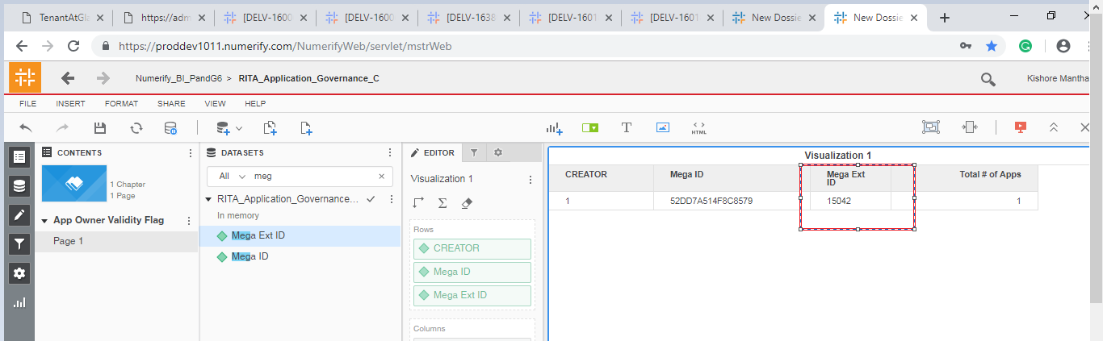

Issue 4: ‘Data Correctness’ attribute’ data is not matched with redshift.

SELECT d.source_dimension_name,

Count(distinct a.row_id) as cnt

FROM ldb.f_rita_application_c_fact a

JOIN ldb.d_rita_application_c b ON a.rita_application_c_key=b.row_key

JOIN ldb.d_rita_application_ext_c c ON b.rita_application_ext_c_key=c.row_key

JOIN ldb.d_lov_mega_data_currentness_c d ON c.data_currentness_c_key=d.row_key

group by 1;

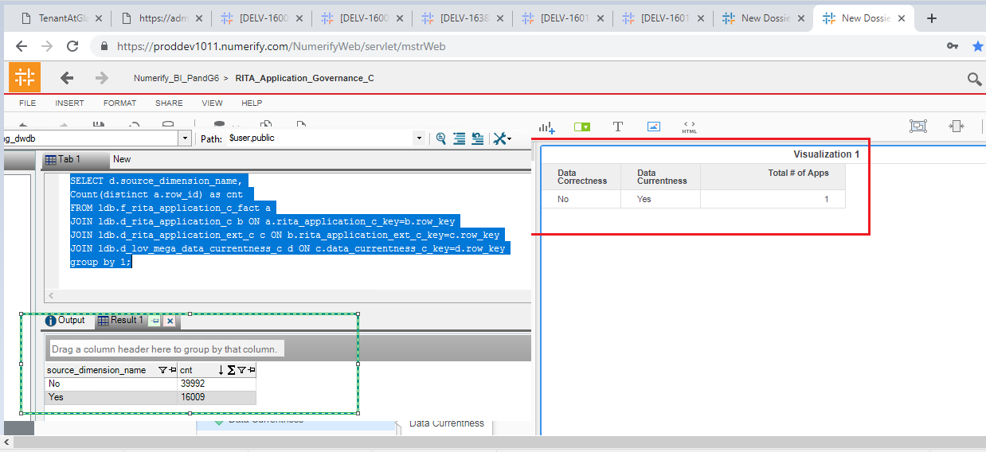

Data Privacy : Multiple Forms.

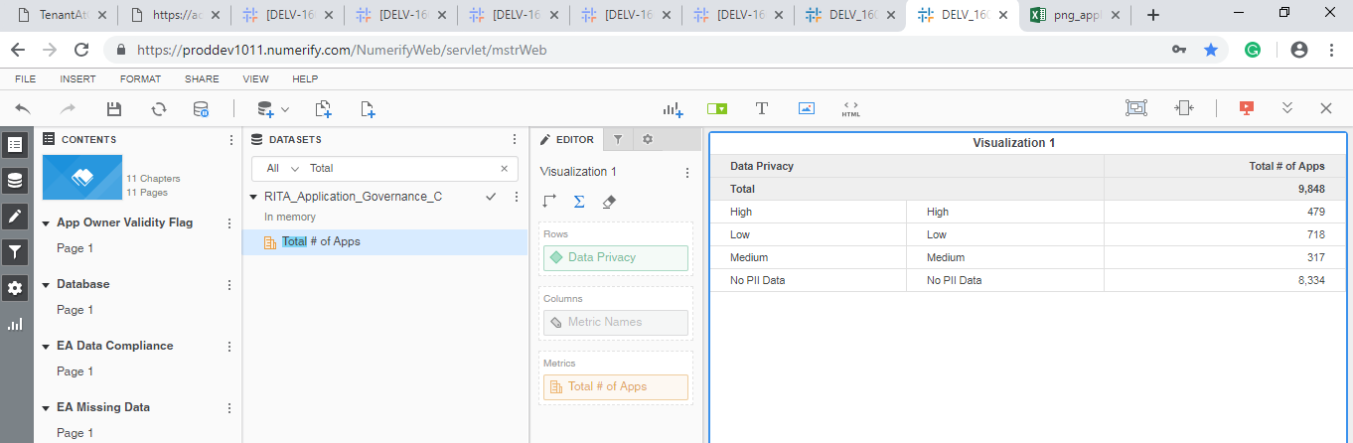

ETL Issues :

Issue 1: ‘Employee Type’ attribute should come from the d_internal_contact and hence, UNKNOW and UNSPECIFIED should not come.



Issue 2: Data Correctness :

SELECT e.source_dimension_name,c.app_owner_validity_flag_c,SUM(a.data_correct_c) AS data_correct_c,

Count(distinct a.row_id) as cnt

FROM ldb.f_rita_application_c_fact a

JOIN ldb.d_rita_application_c b ON a.rita_application_c_key=b.row_key

JOIN ldb.d_rita_application_ext_c c ON b.rita_application_ext_c_key=c.row_key

JOIN ldb.d_lov_mega_data_currentness_c d ON c.data_currentness_c_key=d.row_key

JOIN ldb.d_lov_mega_data_correct_c e ON c.data_correct_c_key=e.row_key

JOIN ldb.d_processing_activities_managing_organization_c a12 ON a.managing_organization_c_key=a12.row_key

JOIN ldb.d_lov_processing_activities_ot_life_cycle_status_c a13 ON b.application_lifecycle_status_c_key=a13.row_key

JOIN ldb.d_lov_processing_activities_ot_repository_type_c a14 ON b.application_nature_c_key=a14.row_key

JOIN ldb.d_application_pg_asset_owner_c a15 ON a.pg_asset_owner_c_key_c=a15.row_key

WHERE

(

a13.source_dimension_name IN ('Design/Build','Discovery/Requ.','Exception','Leverage/Optimize','Launch/Deploy',

'Qualify/Deliver','Retired','Sunset','Undecided','UNSPECIFIED')

AND

a14.source_dimension_name IN ('Generic','XOApplication','XOPlatform','Platform')

)

group by 1,2;

Issue 3: Validation Compliance Attribute is displaying NULL , this was fixed and working fine before.

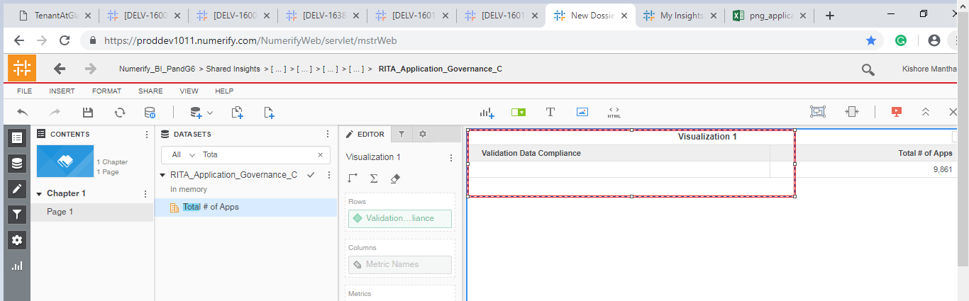

Issue 4 : ‘% Registration Compliance’ metric is not working fine.

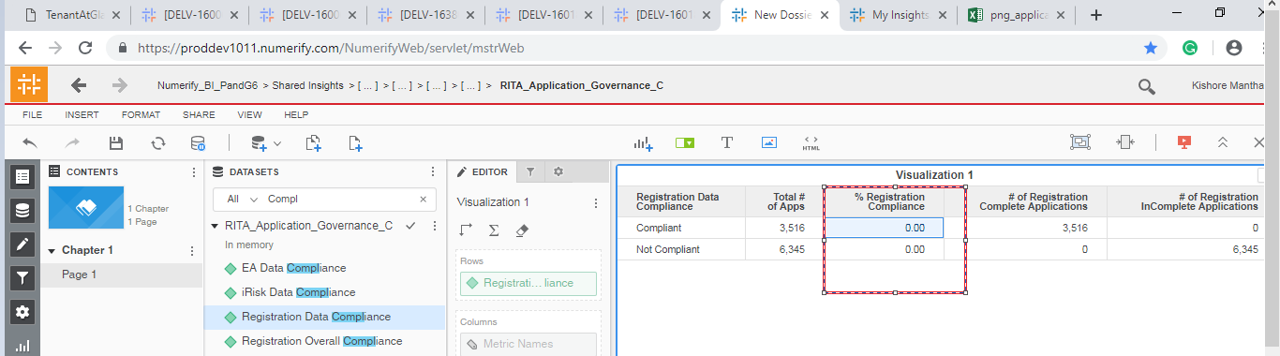

Issue 5: Data Current and Data Correct are displaying 0 and 1 , not sure of the functionality and metric definition.

